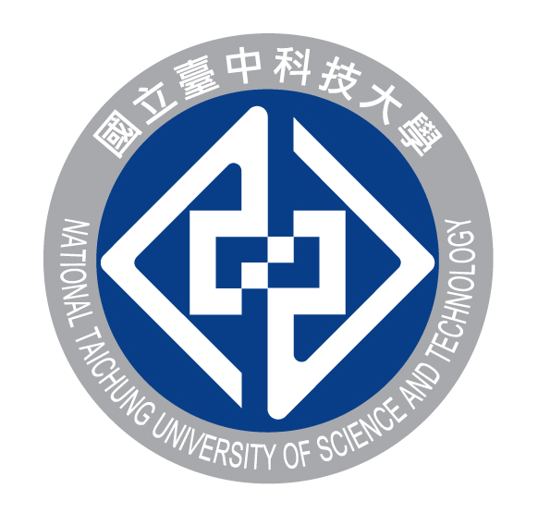
NATIONAL TAICHUNG UNIVERSITY OF SCIENCE AND TECHNOLOGY
No.129,Sec.3,Sanmin Rd,North Dist.,Taichung City 404, Taiwan
Tel: +886-4-2219-5755 Fax: +886-4-2219-5761
E-mail: oia40@gm.nutc.edu.tw Website: http://wwwen.nutc.edu.tw/

APPLICATION FOR TAIWAN SUMMER CAMP PROGRAM

Name | ____________ ___________  First Name / Family Name
Nationality |  |  | Passport NO
Date of Birth | _______ _______ _____  yyyy / mm / dd |  | Gender |  | ☐ Male ☐ Female
E-mail |  |  | Cell Phone
School Name
Course | ☐ High School ☐ Undergraduate ☐ Master ☐ Doctor
Major |  |  | Grade |  | ☐ 1 ☐ 2 ☐ 3 ☐ 4
Date of Participation | 2019.8.19(Mon)~8.30(Fri)
Pick-up | ☐ I need Pick-up service ☐ I don’t need anything
Language Proficiency | English | ☐ Advanced  ☐ Intermediate  ☐ Beginner |  | Chinese |  | ☐ Advanced  ☐ Intermediate  ☐ Beginner
Under the Article 17 and 22 of the Personal Information Protection Act, National Taichung University of Science and Technology will collect and use above personal information for NUTC program and summiting this form you hereby agree to provide personal information.
- Purpose of collecting personal information: to facilitate NUTC’s Taiwan summer camp program(disseminating news about NUTC)
- Collection list: Necessary personal information to facilitate NUTC’s Taiwan summer camp program (disseminating news about NUTC)
All personal information will be retained and used for 2 years

Date : ________________

Signature : ______________

