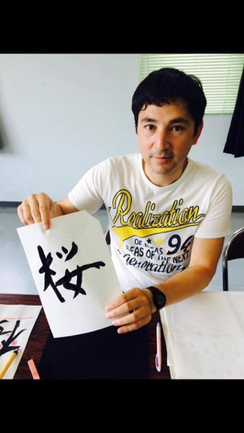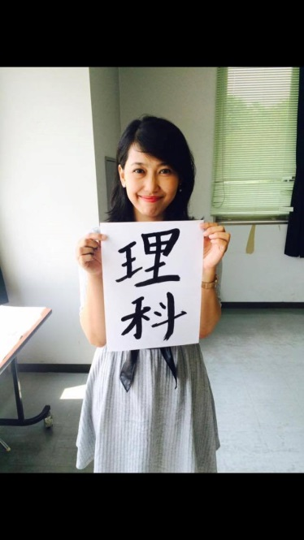

Free Japanese class for

family members of International students,

and International researchers and their families

**広島ライフを楽しむための**

**日本語クラス**

**○：　と**

**この，をはじめてするのためのです。**

**(10月10, 13,17, 20日はおためし授業です。)**

○**Introductory class: Every Tuesday and Friday**

**Suitable for those who have no experience of studying Japanese.**

**(Classes on October10, 13,17, 20 are trial classes.)**



：　**と**

**このは，をしたことがあるのためのです。**

**（10月11,16, 18日はおためし授業です。）**

* **Elementary Class: Every Monday and Wednesday**

**Suitable for those who have a little experience of**

**studying Japanese.**

**(Classes on October 11,16, 18 are trial classes.)**

問い合わせ先/Inquiry：学生プラザ3階/ Student Plaza 3rd floor

Tel: 082-424-5593 Fax: 082-424-4545

Email: kokusai-ryugaku@office.hiroshima-u.ac.jp



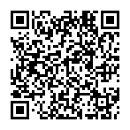



問い合わせ先/Inquiry：学生プラザ3階/ Student Plaza 3rd floor

Tel: 082-424-5593 Fax: 082-424-4545

Email: kokusai-ryugaku@office.hiroshima-u.ac.jp