**【Held on Friday, April 11th 】Recruitment of Participants for the SENSEKI GARDEN Tour Event**

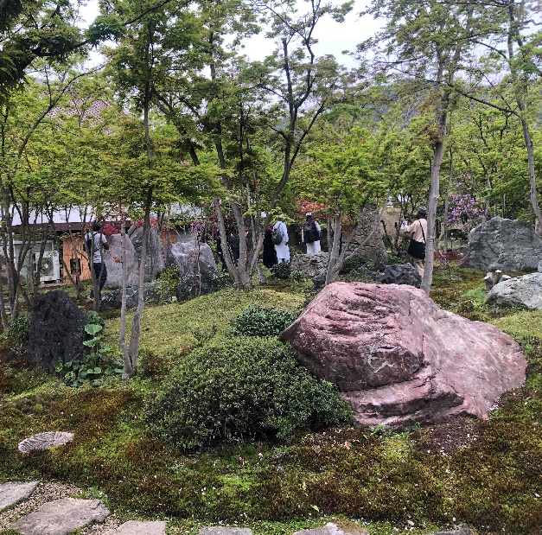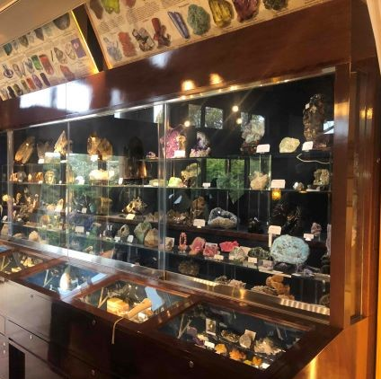

Wish this finds you well. This is the Global Exchange Group of Hiroshima University.

SENSEKI GARDEN offers tour to students, faculty and staff members of the University on the second and fourth Friday of each month.

It is one of the most famous stone gardens in Japan, created by Seizo Yamana, a physician and landscape architect who was the founder of the Yamana-kai medical corporation.　Why don’t you explore the beauty of Japan?

To apply for Friday, April 11th event, please check the participation requirements below before applying.

During the tour, the staff of SENSEKI GARDEN will provide guidance in Japanese. Participants who are proficient in both Japanese and English may be asked to assist in translating for English speakers. Thank you for your cooperation and understanding.

【Location】

・SENSEKI GARDEN (1589-7, Takayahori, Takaya-cho, Higashihiroshima-city)

<https://senseki.org/>

【Target Participants】

1. International students enrolled at Hiroshima University.
2. Japanese students who are fluent in English enrolled at the university.
3. Researchers and staff members of the University.

**Capacity: 20 participants each time. (We plan to close the recruitment once the capacity is reached.)**

**※If there are 9 or fewer participants or due to weather condition, the tour will not be conducted.**

【Participation Fee】

・Admission fee and shuttle bus are free of charge.

【Participation requirements】  
① Free admission is limited to the aforementioned members.  
② Others may attend if vacancies are available, but they must pay the regular entrance fee（For adult） of ¥1,000.  
**③The participants are required to post your visit on SNS, and email your impression to the garden by email (info@senseki.org).**  
【Schedule in details】

12:45 Gather at the entrance of the Student Plaza, 1st floor, Hiroshima University

13：00　**※Bus will leave at 13:00; if you are late, you will not be allowed to participate.**

**Please be sure to notify us in advance if you will be absent.**

**The tour is kindly provided by SENSEKI GARDEN. Please do not miss the tour without notice as there is capacity.**

13:00 - 13:30 Go to SENSEKI GARDEN by shuttle bus

13:30 - 15:30 Guided tour of SENSEKI GARDEN  
15:30 - 16:00 Bus transfer to the Student Plaza of Hiroshima University

**【Application Period】**

**★For Fri, April 11th→From Mon, Mar 31st to Mon, April 7th　at 17:00 p.m. (Deadline)**

※Each tour is from 13：00 ～16：00

Reservations must be made during the following application period. (Deadline is 17:00 on the last day of the application period.)

【Upcoming Schedule and Application Period 】

・For Fri, April 25th→From Fri, April 14th to Fri, April 21st.

・For Fri, May 9th→From Mon, Apr 28th　to Mon, May 5th.

・For Fri, May 23rd→From Mon, May 12th to Mon, May 19th.

【Application　Form】

<https://forms.office.com/r/SMwYpZZcQx>

※You will receive an email if your application is confirmed.

**For absences, please report to us at the inquiry e-mail address below.**

＜Inquiry＞  
Global Exchange Group (Student Plaza 3F)

Ruka SUMIDA (Ms.)

E-mail: [kokusai-sien@office.hiroshima-u.ac.jp](mailto:kokusai-sien@office.hiroshima-u.ac.jp)