**International Night**

1. Overview

The purpose of this event is to promote international exchange by having international students from various countries and regions introduce their own cultures and exchange opinions with participants. It is usually held once a month from 6:00 p.m. to 7:30 p.m. in the east side free space on the 1st floor of the Student Plaza and in the Global Learning Center on the 3rd floor of the West Library.

2. Event Contents

• Following self-introductions by international students, they will present on their home countries' cultures based on pre-prepared themes.

• There will be a question-and-answer session between international students and all participants.

• Participants will divide into groups and engage in discussions on the day's main theme, including presentations on their home countries' cultures.

• The event will conclude with a survey and a group photo.

3. Activity Examples

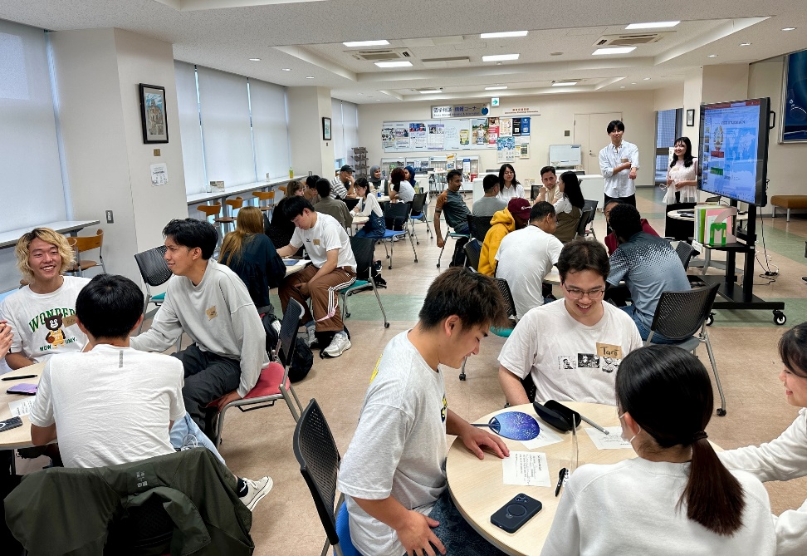2025/5/26

2025/6/24

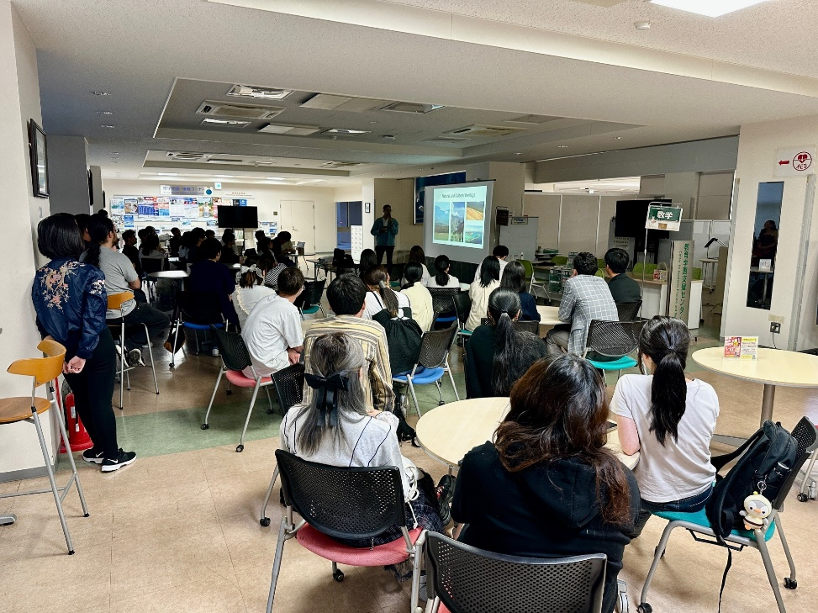

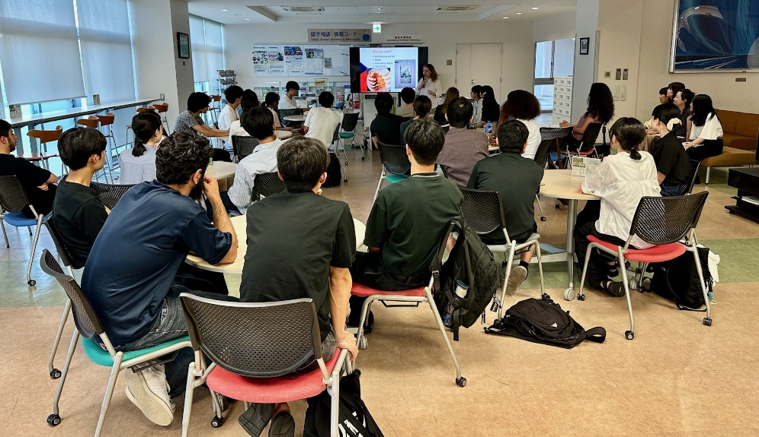2025/7/22