**International Party**

1. Overview

We regularly plan and hold international exchange events with the aim of providing Japanese students and international students with opportunities to enjoy interacting with each other and learning about different cultures through games and topic discussions using English and Japanese. These events are held two to three times a month, usually in the evening (6:00 p.m. to 7:30 p.m.) in the free space on the east side of the 1st floor of the Student Plaza.

2. Event Contents

① Table Setup

First, we arrange seating so that international students and Japanese students are mixed together in groups. With diverse members at each table, everyone can quickly make new friends!

② Icebreaker: Topic Discussion

The event begins with a light warm-up! Groups introduce themselves. Chat casually and naturally get to know each other.

③ Team Game Time

From here on, it's 45 minutes of games! We'll focus on team-based games, so you can have fun interacting with even more people!

④ Closing

Finally, we'll ask for your cooperation in filling out a survey, take a group photo with everyone, and conclude the event!

3. Activity Report

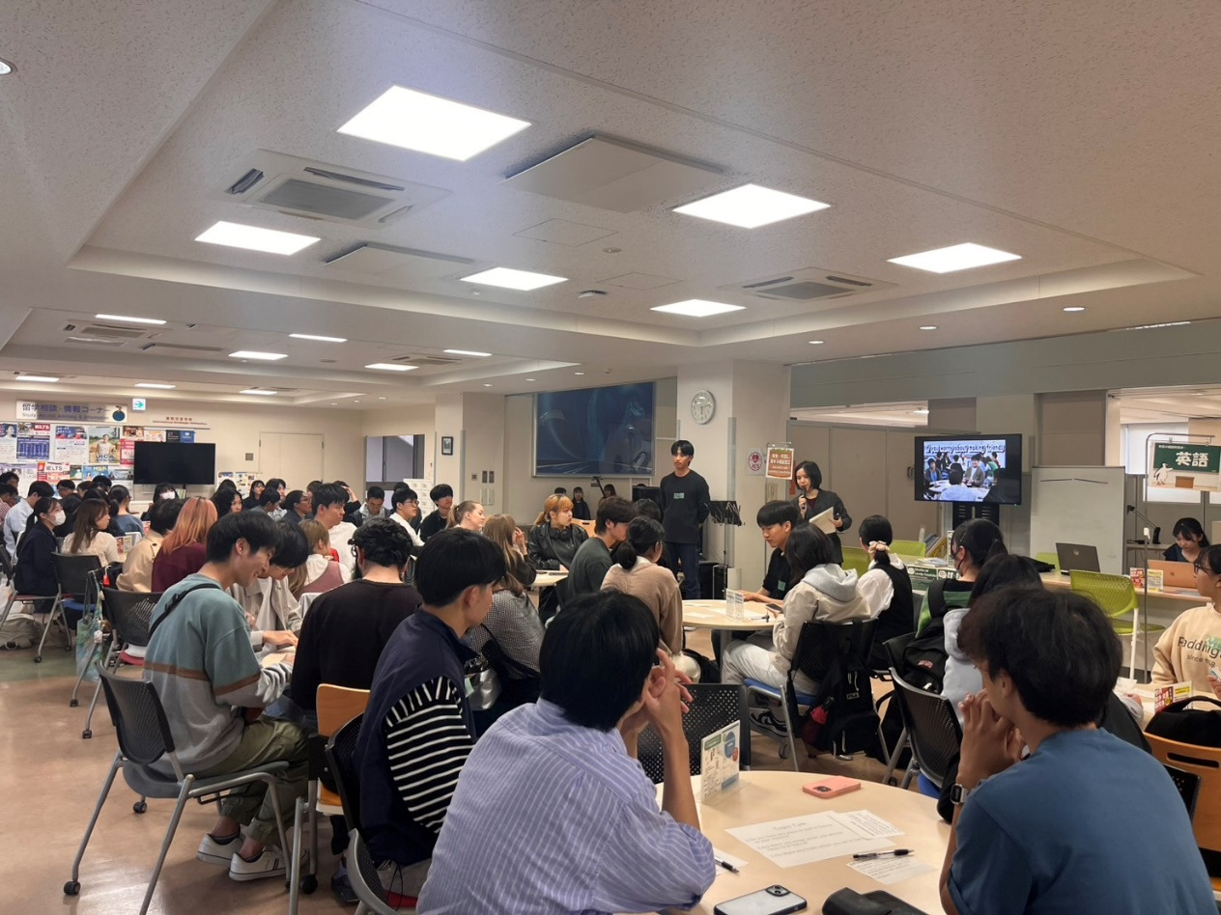2025/4/28

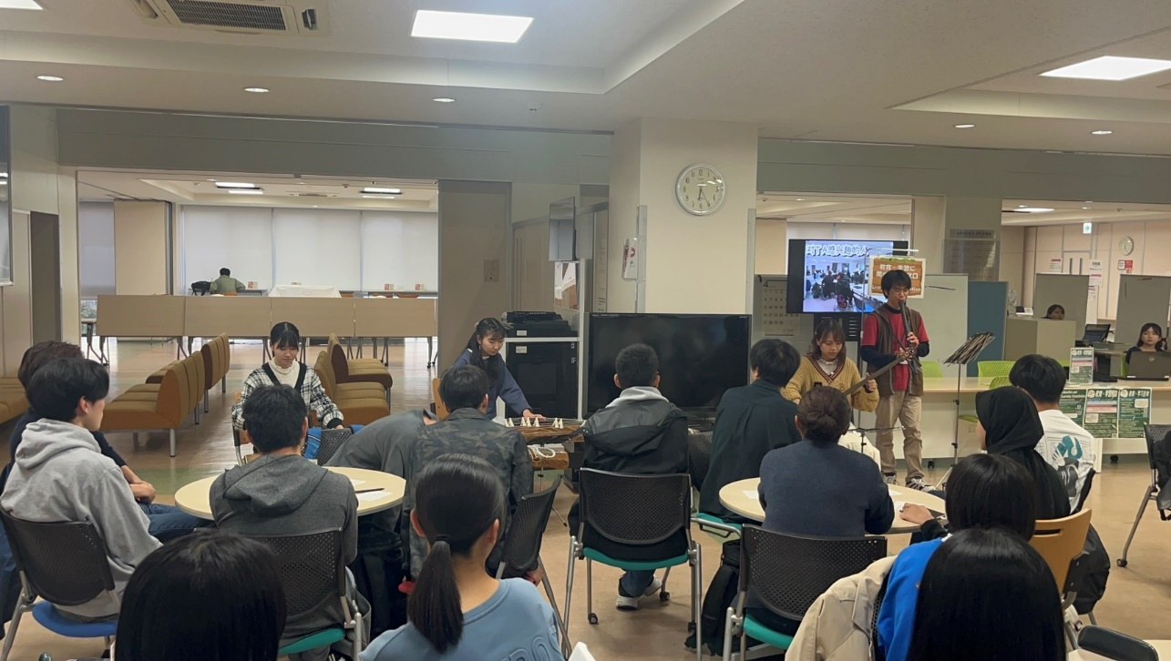2025/4/28

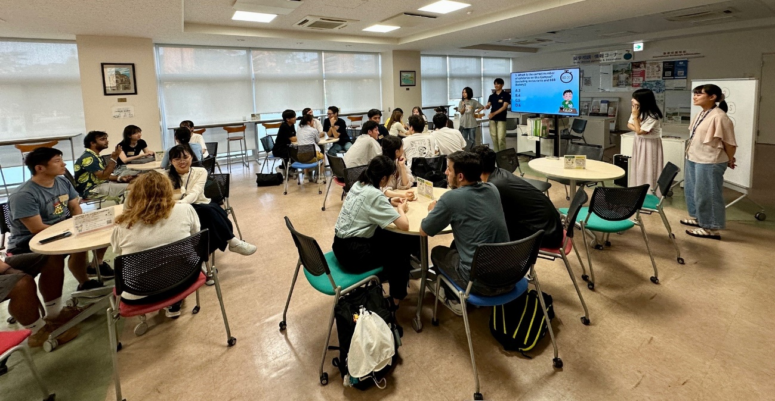2025/7/15