
Call for application of “Hiroshima Orizuru Fellow”

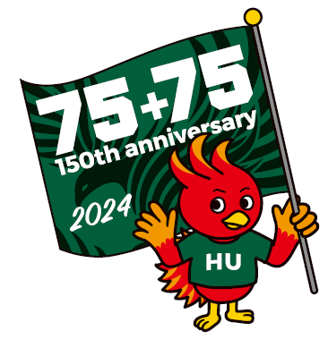

HU&SPF&CU Summer Course
on Peace and Sustainability 2025

August 2-August 10, 2025
at Higashi-Hiroshima campus, Hiroshima University

“Clinic on Conflict and Collaboration in Natural Resource Management – Advancing Positive Peace and the SDGs”

1．Background
Around the world, competing demands for natural resources as well as societies’ reliance on ecosystem services create practical management challenges that have led to multiple crises like climate change, biodiversity loss, and loss of identity and sovereignty for local communities. In response, the international community has established aspirational agreements like the Sustainable Development Goals to reverse or mitigate those challenges. However, conflict among private sector interests, private landowners, conservation and non-profit organizations, and state, county, and local communities often inhibits progress toward implementing agreements and achieving targets. Research increasingly highlights the role that collaboration and peacebuilding can play in overcoming conflict and enabling substantive progress in achieving sustainability goals, particularly through natural resource management. This program provides an in-depth exploration of the drivers of conflict in contemporary natural resource management and practical approaches to overcoming impasse. Natural resource conflicts are unique because they require solutions that are both collaborative and environmentally sustainable. This requires that stakeholders and resource managers understand the technical boundaries of sustainability as well as each other’s needs, interests, and positions.

The summer program will be aligned with ongoing research by the instructors into regional sustainability issues in Japan associated with localization of the Sustainable Development Goals (SDG). The course will explore the connections between SDG 16 (Peace, Justice, & Strong Institutions) on one hand, and SDG 11 (Sustainable Cities & Communities), SDG 6 (Clean Water & Sanitation),13 (Climate Action), 14 (Life Under Water), & 15 (Life on Land). Students will undertake virtual data collection using secondary desk research as well as through participant observation and site visits with representatives of stakeholder groups. Students will learn to collect and analyze physical samples of water quality and will learn how to incorporate environmental data into policy processes. The clinic will also consider peace in a narrow sense through actual experiences in the A-bombed city of Hiroshima, which will mark the 80th A-bomb anniversary on August 6. This will provide students with insight into the diplomatic, international, and municipal legacies of conflict and how societies can move forward toward more peaceful and sustainable futures.

Learning Objectives
Through a combination of workshops, classroom instruction, field visits, & independent research, the program will enable students to:
- Integrate multiple types of data (quantitative, qualitative, geospatial, etc.) to identify the natural resources at stake in an environmental conflict and the technical aspects of sustainable resource management
- Analyze stakeholder needs, interests, and positions in order to understand the drivers of conflict;
- Conduct institutional review to assess the legal and administrative governance of resource and conflict management;
- Synthesize research findings and evidence-based policy recommendations via policy briefs that are targeted to stakeholder audiences and broader popular audiences.

Note: Students who complete the course will be awarded the title of “Hiroshima Orizuru Fellow”, and will be expected to contribute to the realization of a peaceful and sustainable society continuously. The course sponsors may invite the students to participate in related international conferences in the future.

2．Program (tentative)
(1) Program in Hiroshima
 |  | AM (9:00-12:30) | PM (13:30-17:00)
Aug 2 | Sat | Course Registration/Orientation  Opening Ceremony/Presentation | Lecture on Water Quality Management  Sake Brewery “Kamotsuru”  Welcome Party
Aug 3 | Sun | Lectures and conceptual foundations | Positive Peace Workshop
Aug 4 | Mon | Dialogue and discussion with Hibakusha (survivors of the Hiroshima bombing) | Training and preparation for fieldwork
Aug 5 | Tue | Training and preparation for fieldwork (continued) | Lectures and practitioner perspectives
Aug 6 | Wed | Peace Memorial Ceremony  Peace Memorial Museum | Lantern Floating Ceremony (Optional)
Aug 7 | Thu | Fieldwork in Etajima  Group 1- Yanagawa Oyster Farm  Group 2- Olive Lab  Group 3- Olive Factory | Satoumi Science Museum
Aug 8 | Fri | Data processing/Analysis/Group work | Preparation of policy positions
Aug 9 | Sat | Policy negotiation simulation | Closing Ceremony  Farewell Party
Aug 10 | Sun | Free Day in Miyajima or Downtown Hiroshima (Optional) | Free Day in Miyajima or Downtown Hiroshima (Optional)

Application
- Number of applicants from each university: 4 from HU partner universities, 12 from HU
- Academic year: Undergraduate (juniors/seniors) and Graduate students (enrolled in Master’s and Doctoral courses) students
- Requirements:
- Those who can basically participate in all the classes during the program period.
- Applicants must be able to talk about the current situation and challenges in their home country, country of residence or region.
- Applicants must have a strong interest in nature conservation, the goals of SDGs 13, 14 and 16 and a sense of mission for peacebuilding (regardless of expertise).
- Be willing to listen to lectures, work in groups and give presentations in English.
- The participants must be able to comply with the rules and regulations and participate in the entire program.

(4) How to apply
Please fill out the attached form and submit to your office in charge
Deadline: Strictly 17:00 JST on Friday May 16, 2025.

5．Fees
- Program fees: Free of charge (incl. lectures, excursion, welcome & farewell party)
- Other fees paid by participants:
(For students outside Japan) Air fare, transportation from airport to Higashi-Hiroshima, accommodation (booked by HU) and meals

6．Digital badge and credit
- A digital badge will be provided for the attendees on the last day of the program.
- Please ask details about credit at your university’s office in charge.

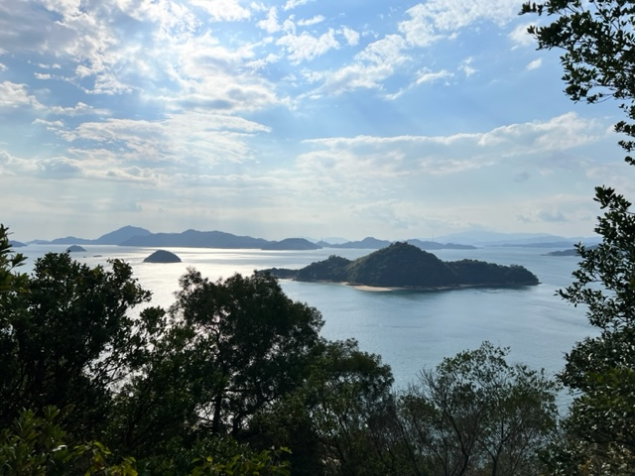
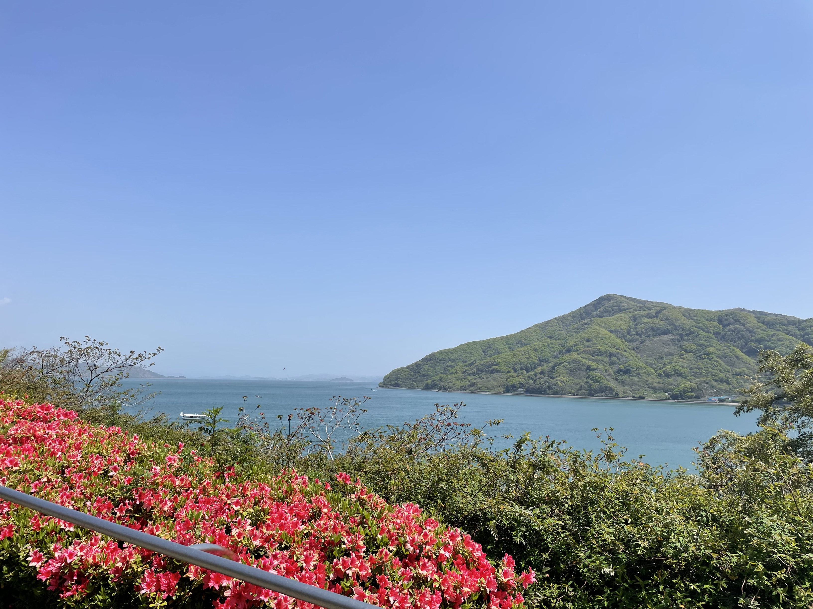
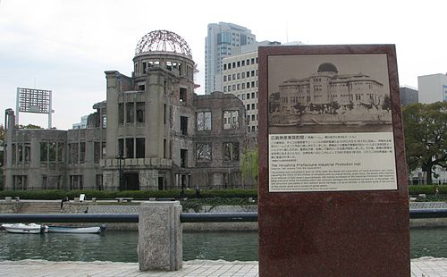
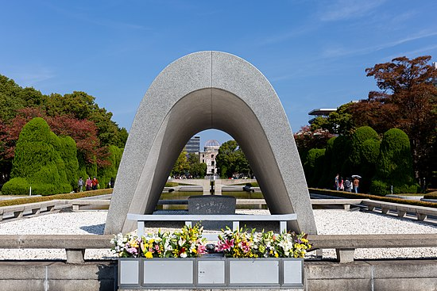
Seto Inland Sea
Peace Memorial Park

